Mark 3 IEC Fusion Reactor Vacuum Chamber Specifications

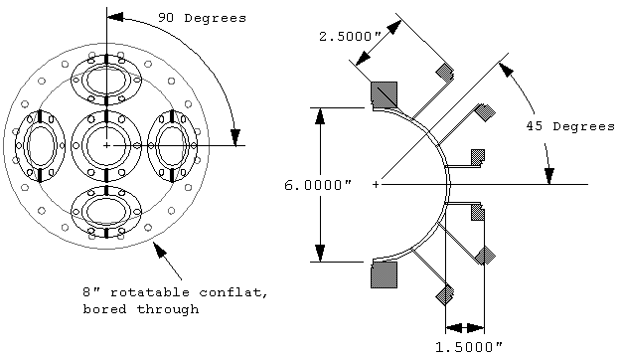
Figure 1. Vacuum chamber dimensions.

The reactor core will consist of a 304 SS spherical vacuum chamber equipped with 8 off axis ports for ion injectors and instrumentation, and two on axis ports for vacuum system connection and grid feed through. The spherical vacuum chamber will be constructed out of a pair of 6” diameter, 1/8” thick hemispheres coupled together with 8” rotatable conflat flanges. Each of off axis ports will consist of a 2.5” long 2.75” conflat half nipple equally positioned 90 degrees apart in azimuth and 45 degrees in elevation off the vertical axis. The on axis ports will consist of 1.5” long rotatable 2.75” conflat half nipples. Each of the ports will be aligned so that the relative axis of each port intersects at the center of the hemisphere, allowing deuterium beams from each of the ion injectors to converge at a focal point in the center of the accelerating grid.
The holes bored in the hemisphere are 1.495” in diameter to ensure a snug fit of the half nipple, thereby ensuring a good quality TIG weld. The 8” rotatable conflat flanges are turned down on a lathe, removing the internal weld lip and allowing the face of the hemisphere to be positioned flush to the face of the rotatable conflat ring. To compensate for the thickness of the o-ring used to seal the 8” conflat flanges together, 0.045” is removed from the height of the hemisphere, thereby ensuring the vacuum chamber remains spherical when assembled.

Components:
Core Components | Supplier | Part # | Quantity | Each | Total
6" SS hemisphere | sharpeproducts.com | H600-SS | 2 | 36.55 | 73.1
8" bored through rotatable conflat | mdcvacuum.com | 110031 | 2 | 110 | 220
2.75" Non-rotatable Conflat Weld Stub | mdcvacuum.com | 401002 | 8 | 31 | 248
2.75" Conflat Nipple | mdcvacuum.com | 402002 | 2 | 55 | 110

Additional Notes:
The conflat nipples are cut in half to get a non tapped rotatable conflat half nipple. On the mark 3 core, eight 2.75” conflat nipples were acquired at a low price of approximately $10 each and cut apart on a lathe to produce non rotatable half nipples that were 2.5” long; identical to those commercially available. The remaining rotatable half nipples were approximately 1.5” long and were used for the on axis ports. Depending on what resources are available, it may be less expensive to buy non-rotatable half nipples if this chamber is to be reproduced, however rotatable half nipples are hard to locate and may have to be cut from a full nipple.

The interior and exterior of the hemispheres are polished with up to 2500 grit silicon carbide sandpaper. The smooth interior surface will enable the reactor to be cleaned more effectively as fewer contaminants would be trapped in the surface. The core should not be electro-polished as this will form a passivation layer and would interfere with the welding process.

A weld relief groove is machined into the face of the rotatable conflat ring to assist in the TIG welding process by providing two metals of equal thickness to weld. This equalized heat dissipation and ensures that both sides of the but weld melt at the same time during the weld process (see welding requirements sheet).

